**TUẦN 8**

**UNIT 3: A TRIP TO THE COUNTRYSIDE**

**TIẾT 16:**

**Task 1. What do these people wish? Write the sentences.**

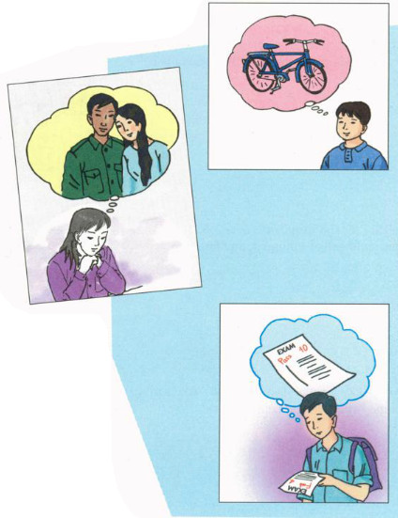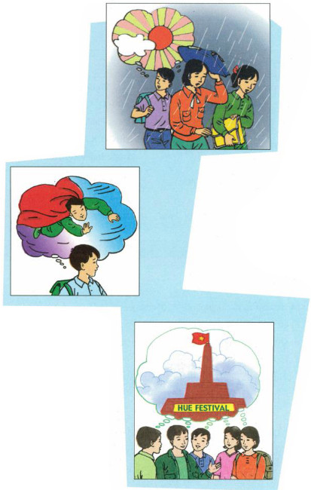

a) Ba/ can have/ new bicycle

b) Hoa/ can visit/ parents

c) I/ pass/ exam

d) We/ it/ not rain

e) He/ can fly

f) They/ stay/ Hue

**Task 2. Work with a partner.**

**Look at Mr Thanh’s itinerary for his business trip to Singapore. Complete the sentences. Use the prepositions in the box.**

|  |  |
| --- | --- |
| Itinerary for *Le Huy Thanh* | |
| Monday, September 20  Depart: Ha Noi / 2 pm  Arrive: Singapore / 6.30 pm  Tuesday, September 21  MEETING  Rallies Center / 11 am -1 pm  LUNCH  Lion City Restaurant / 1.30 - 2 pm | Wednesday, September 22  MEETING  Raya Palace / 2.15 - 7 pm  DINNER  Little India Restaurant / 7.30 - 10 pm  Thursday, September 23  Depart: Singapore / 9 am  Arrive: Ha Noi / 11.30 am |

|  |
| --- |
| at      till        on        after       up         to         between |

a) Mr Thanh leaves Ha Noi ___ 2 p.m.

b) He arrives in Singapore ___ Monday evening.

c) On Tuesday morning, there is a meeting ___ 11 a.m. and 1 p.m.

d) On Wednesday, Mr Thanh has appointments ___ 10p.m.

e) He returns to the hotel ___ 10 p.m.

f) He will be in Singapore from Monday ___ Thursday

**Task 3. Complete the sentences with ON, AT, IN, FOR**

a) Goodbye. See you ___ Monday.

b) The bus collected us ___ 5 o’clock early ___ the morning.

c) We usually go to our home village at least once ___ the summer.

d) We walked ___ half an hour to roach the waterfall.

e) They planned to have the trip ___ June.

f) She loves to watch the stars ___ night.

**Task 4. Match the half-sentences. Then write the fill sentences in your exercise book.**

|  |  |
| --- | --- |
| 1. Hoa worked hard,... | a) so I turned on the air conditioner. |
| 2. It was hot,... | b) so she didnỵt have time for breakfast |
| 3. Nga is sick today,... | c) so Mrs. Robinson took it back to the shop. |
| 4. Na woke up late,... | d) so she won't go to school. |
| 5. The new camera didn't work,... | e) so she passed her exam. |

***LƯU Ý*** :

* ***Phần A: từ vựng (VOCABULARY) bao gồm 2 phần*** :

+ Từ mới đã được giáo viên giảng dạy trong các clip đính kèm .

+ Ôn lại các từ quan trọng trong bài học ( nếu học sinh có quên cách đọc các từ này có thể tra cứu bằng từ điển online trên GOOGLE hoặc hỏi trực tiếp giáo viên bộ môn)

* ***Phần B***: là nội dung sách giáo khoa (TEXTBOOK CONTENTS) dành cho những em chưa tiếp cận được sách giáo khoa giấy, điện tử .